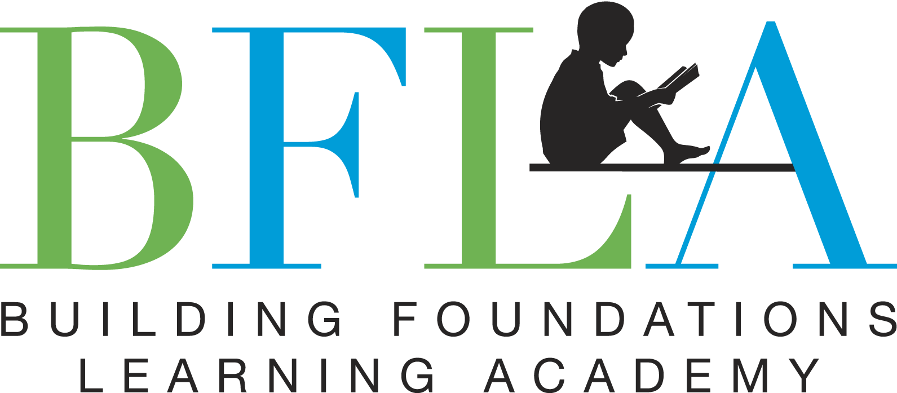

Building Foundations Learning Academy is hiring for various positions. Due to the COVID-19 pandemic and our expansion that is in progress (we are opening another location), we want to add substitute teachers, part-time staff to assist virtual learners, administration and fulltime teachers to our Quality Rated organization. Review the positions below and if you feel like this could be a fit for you, email your resume to buildingfoundationsacademy@gmail.com

Substitute and Lead Teachers

**Responsibilities:**

* Instruct children in activities derived from the Georgia Early Learning and Development Standards (GELDS) that promote intellectual and creative growth
* Create a fun and safe learning environment
* Guide children to learn language, gain autonomy, interact socially and enjoy physical activity
* Establish and maintain positive relationships with students, parents and other daycare staff
* Communicate with parents on students' growth and progress
* Maintain the health and safety of all students
* Implement Quality Rated policies and procedures
* Complete annual Bright from the Start education requirements

**Qualifications:**

* Previous experience in childcare (minimum 2 years)
* Passionate about working with children
* Ability to build rapport with children
* Positive and patient demeanor
* Excellent written and verbal communication skills
* Completed Cogent background check
* CPR/First Aid certification
* Child Development Credential

**Administration**

**Responsibilities:**

* Draft newsletters, correspondence and other formal documents
* Supervise Quality Rated process (will be trained)
* Post and update social media platforms
* Weekly grocery shopping
* Enter payment records into Quickbooks
* Fill in classrooms/kitchen when needed
* Keep and organize vehicle records and plan maintenance.
* Plan and schedule appointments and events
* Greet and assist onsite guests; provide tours
* Answer inbound telephone calls
* Develop and implement organized filing systems
* Perform all other office tasks

**Qualifications:**

* Previous experience in office administration or other related fields
* Experience in childcare
* CPR/First Aid certified
* Computer skills
* Ability to prioritize and multitask
* Excellent written and verbal communication skills
* Strong attention to detail
* ​Strong organizational skills